**Assignment B| Website Development**

B.P2 Produce designs for a website that meet client requirements

# Statement Requirements

## **Client Requirements**

I have recently joined Hot Beans Web as a junior web developer. The business owner has asked me as part of my induction and training to create a new website for the company which will promote the company to prospective employees as Hot Beans need to recruit more web developers. I need to include the following things:

* A profile on the company itself
* Profiles of existing trainee web developers
* Job specifications and required qualifications
* An on-line application forms
* Links to web development courses

## **Intended audience**

The target audience has to be people who have completed training courses or qualifications related to web development and are now looking for jobs as web developers. The job seeks people that preferably finished a degree in a university making the age group desired for the job of around 21-22 as that is when people that go straight from year 12-13 into university finish their studies. Usually, website developers are classy people that you would expect to see in a smart wear, usually young 20s.

## **Problems to be solved**

The problem the company currently has is the lack of website developer employees (as we can tell from the intended audience and client requirements) hence asking me to create a new company website which will attract more employees. The website I am going to create has to be professional and well-structured so it attracts new employees. I must ensure that every information I use is correct to the best of my knowledge and employees have a tab where they can apply and have a variety of information available to them. Due to this job being assigned to me, I can profoundly work on my training and gain experience making me a more valuable person within the company.

## **Constraints that may arise during the project**

It is the first time I ever create a website from scratch therefore I may find it difficult or hard to create one to the best of my knowledge, however it is a good chance to create some personal experience. The software I am going to be using is not a “licensed” software meaning it is free off the internet meaning it may not have the best futures and configurations I may need. Troubleshooting myself out of things is also something I will need to do because I have no-one else who is available to help and support me. Time-related issues is also a problem because I have to finish the whole website in a set time-period.

## **Benefits**

Creating a website not just for Hot Beans Web, but for every company, brings in a big handful of benefits. A good, powerful, strong website can help advertise successfully, sell products with ease and trust and enforce dominance over other companies. In my case, the benefits I/the company will be receiving is that the job can be advertised cost-efficiently and at a high standard making a large audience be aware of the job role and applying making it better for the company as the more people that apply, the higher the chance people with both a degree and experience applying.

## **Interactivity**

The website will be interactive meaning you can browse it, interact with it, fill in details, etc. The website will react to every click for example if you are on the “about us” page and click on the logo, they will get redirected to the home page. The website will also have an application form for the website developer job role which can be filled in by anyone and it will get sent straight to us.

## **Complexity**

The website will have a simple layout however it will be very complex when it comes down to the coding and how far it can go. It will have a simple layout as people prefer things that don’t look too complicated or difficult however it will have the design that would make it look very professional and pleasing to view. The website should work on intuition and the “basic” layout where people know where to find everything before they even enter the website.

# Mind Map

**https://www.canva.com/design/DAGCqNptx_s/qf0Ea0prj8z2rlgo3x0GSg/edit?utm_content=DAGCqNptx_s&utm_campaign=designshare&utm_medium=link2&utm_source=sharebutton**

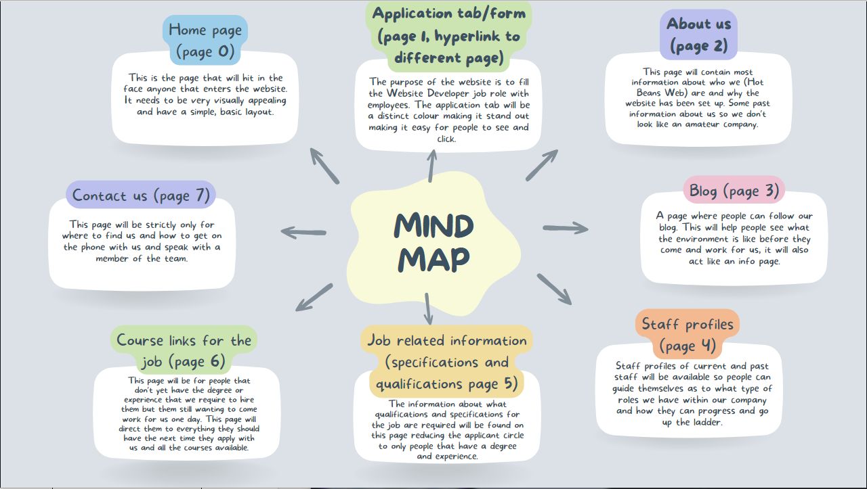

# Mood Board

***BEFORE:***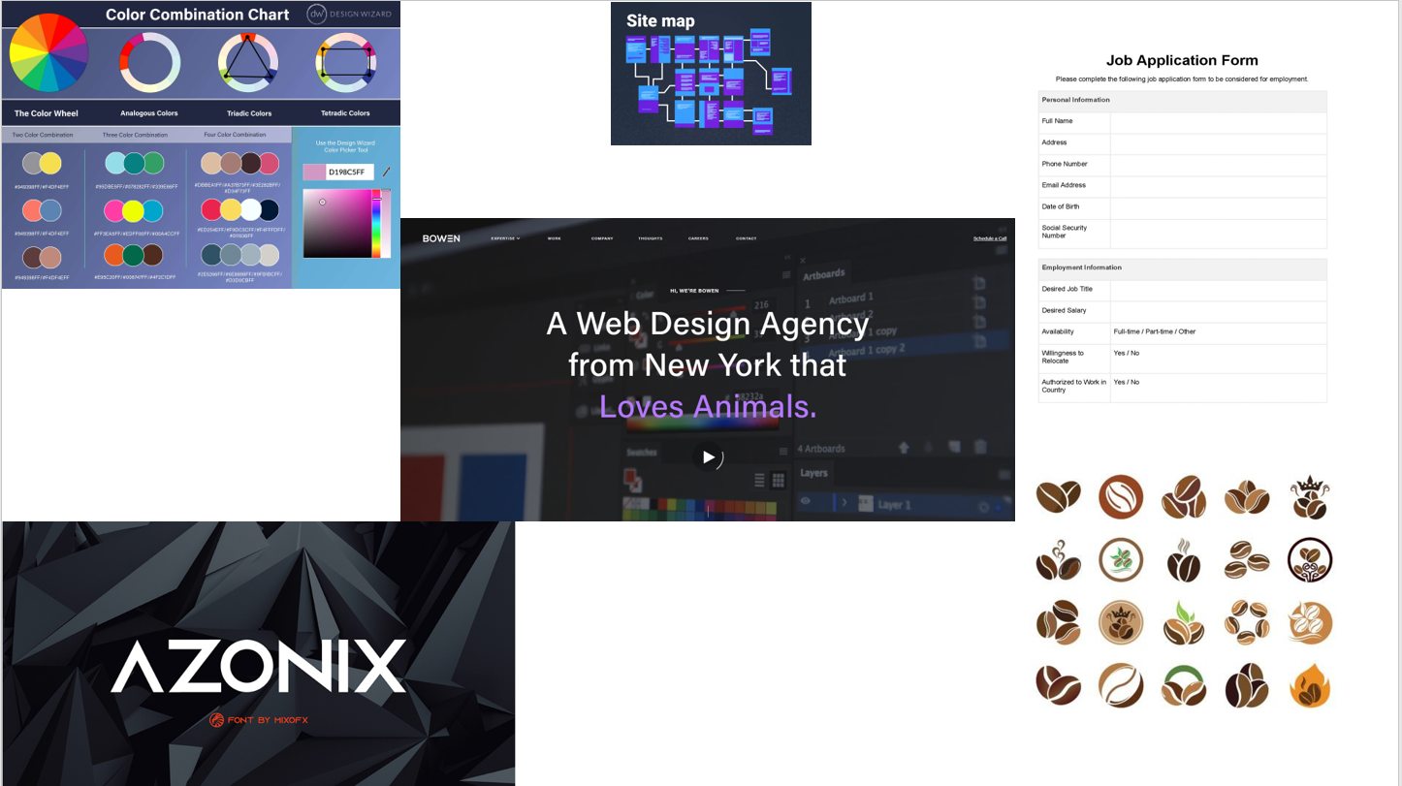

***AFTER:***

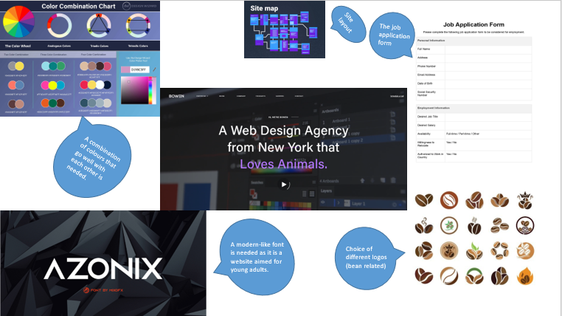

For my mood board I have added different picture e.g. the use of different colours that go with each other, modern font I can be using, different ideas of logos, a sketch job application form, a rough idea of what I want my website to look like.

# Wire Frames

For the website wire frames, I have built 2 different but similar websites designs that run amongst the same layouts which gives me more ideas around building the website with different perspectives. I will look at the pros and cons of both and analyse them.

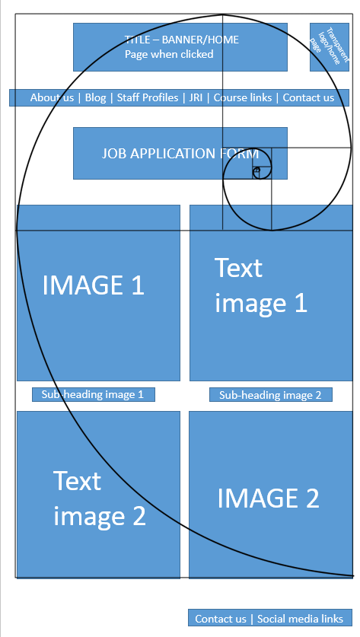

This is my first design which offers a vertical layout of the page, it is pretty crowded and a lot of text and images can be found. The images and text are placed where the reader prefers them most (in the middle of the page) and the links and button are in the default positions where you would find them on all websites. With the right use of colours, this website can be very aesthetically pleasing and very easy to read and navigate. The job application form is a link that will redirect you to a different page and the navigation tab are also links that direct you to different pages.

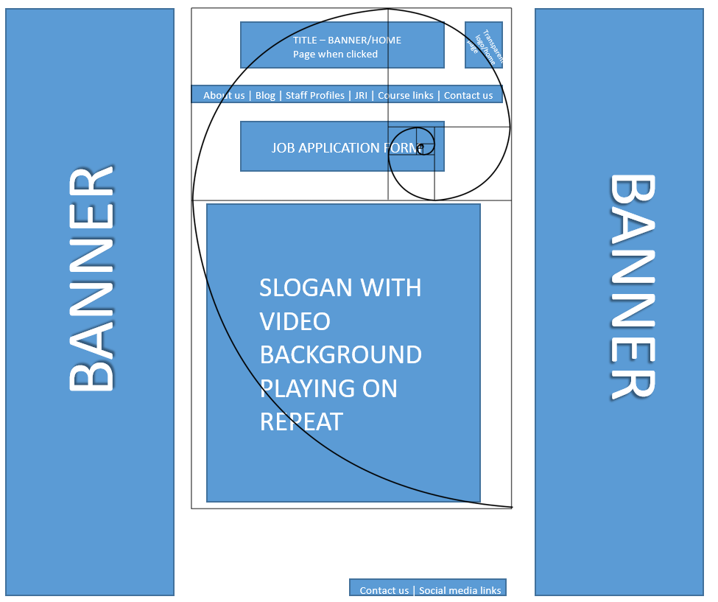

This 2nd design idea is a horizontal layout however it is the type of modern website that you will find top-tier companies having with a video playing constantly on the background while you are reading and acknowledging everything you find on the page.

# Site Map

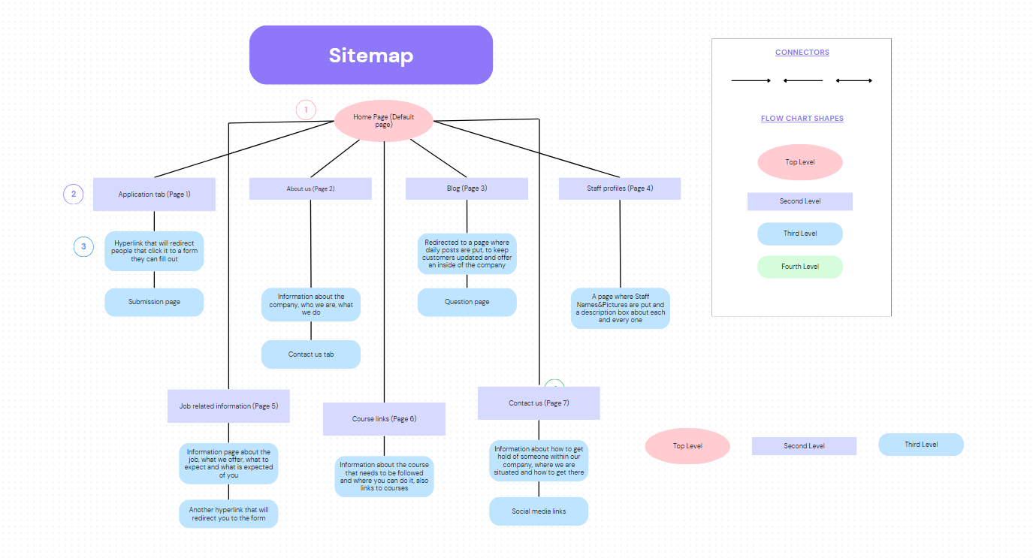

PEER FEEDBACK:

Racheal B: Talk about the mood board a little bit underneath it. The layout of your wireframes is all good and makes good use of the golden ratio, your site map meets the requirements.

Joshua O: I think you have made too many pages however it might not be a problem if you can complete all of them and make them interactive and functional, overall I really like your plan and I think it is really well laid out.

Based on the feedback I have received, I have added more information under the “mood board” section and explained it.

# Wireframes for whole site

For my wireframes section, I have designed a wireframe for each of my 8 pages.

Home page wireframe

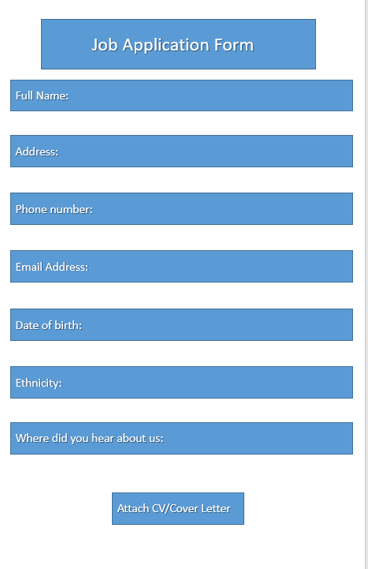Job application wireframe

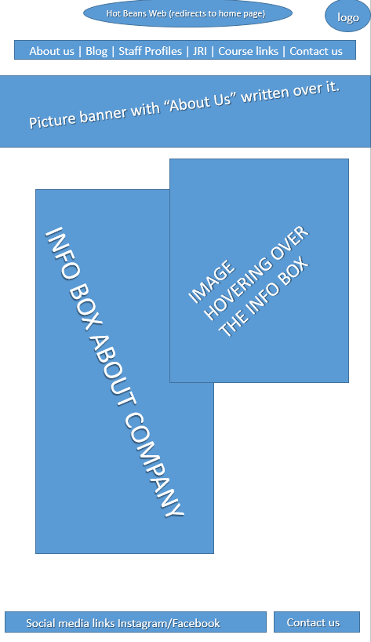About us wireframe

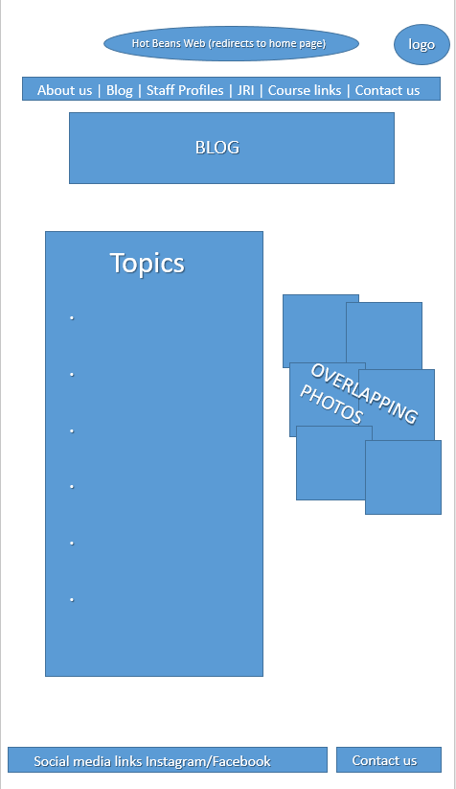Blog wireframe

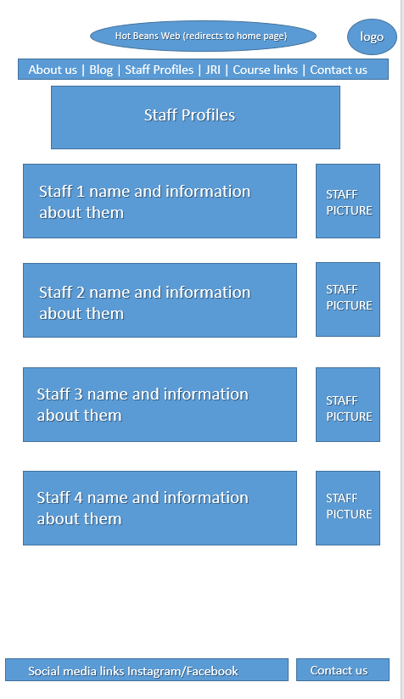Staff profiles wireframe

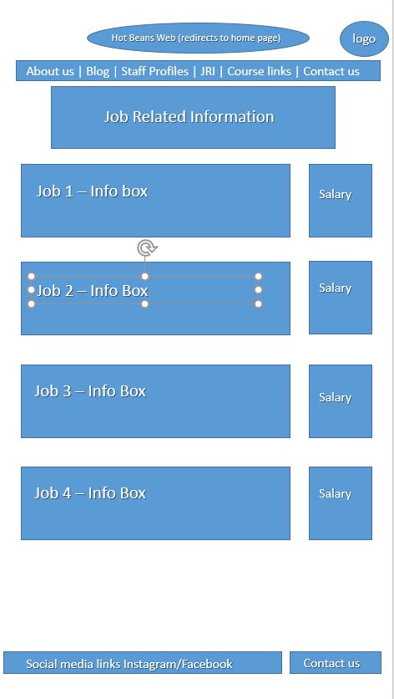Job Related Information Wireframe

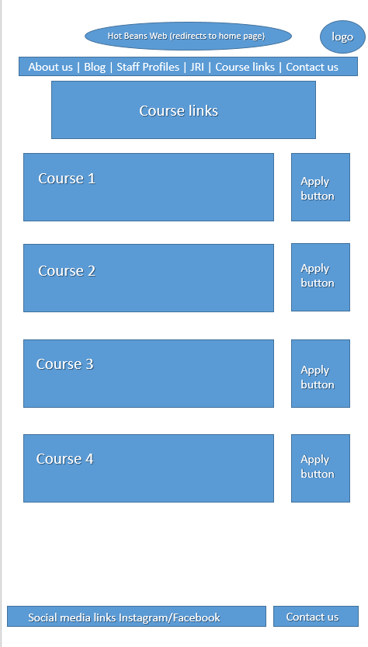Course links wireframe

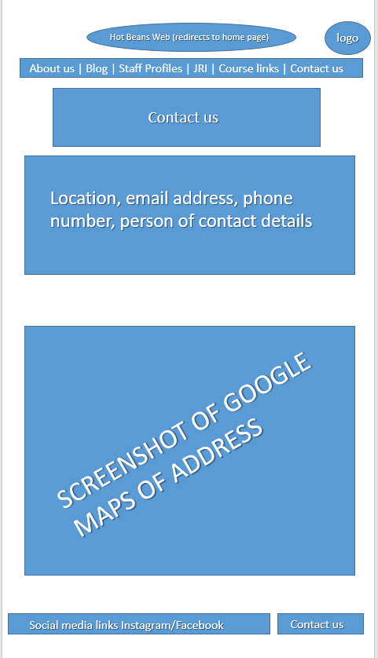Contact us wireframe

# Assets Prep

|  |  |  |
| --- | --- | --- |
| Assets Required HOME | Content | Copyright |
| Logo | Three coffee beans.ai Royalty Free Stock SVG Vector and Clip Art | <https://www.google.com/url?sa=i&url=https%3A%2F%2Fvectorportal.com%2Fvector%2Fthree-coffee-beans.ai%2F14592&psig=AOvVaw2JolFxhmCz3-kxdeugCOIw&ust=1714211838624000&source=images&cd=vfe&opi=89978449&ved=0CBIQjhxqFwoTCIjopO_O34UDFQAAAAAdAAAAABAE>  Creative Commons Licence |
| Information Image 1 | Building Images | Free Photos, PNG Stickers, Wallpapers & Backgrounds -  rawpixel | <https://www.rawpixel.com/search/building>  Creative Commons Licence |
| Headline and short info box | Welcome to our site, Hot Beans Web where everything is weebbbbiiified ! | Self-made |
| Info Box 1 | Top Spec Tech Offices | Self-made |
| Info Box 2 | London’s finest buildings | Self-made |
| Instagram logo | File:Font Awesome 5 brands Instagram square.svg - Wikimedia Commons | <https://commons.wikimedia.org/wiki/File:Font_Awesome_5_brands_Instagram_square.svg>  Creative Commons Licence |
| Facebook logo | File:Facebook icon (black).svg - Wikimedia Commons | <https://commons.wikimedia.org/wiki/File:Facebook_icon_%28black%29.svg>  Creative Commons Licence |

|  |  |  |
| --- | --- | --- |
| Assets Required FORM | Content | Copyright |
| Logo | Three coffee beans.ai Royalty Free Stock SVG Vector and Clip Art | <https://www.google.com/url?sa=i&url=https%3A%2F%2Fvectorportal.com%2Fvector%2Fthree-coffee-beans.ai%2F14592&psig=AOvVaw2JolFxhmCz3-kxdeugCOIw&ust=1714211838624000&source=images&cd=vfe&opi=89978449&ved=0CBIQjhxqFwoTCIjopO_O34UDFQAAAAAdAAAAABAE>  Creative Commons Licence |
| Instagram logo | File:Font Awesome 5 brands Instagram square.svg - Wikimedia Commons | <https://commons.wikimedia.org/wiki/File:Font_Awesome_5_brands_Instagram_square.svg>  Creative Commons Licence |
| Facebook logo | File:Facebook icon (black).svg - Wikimedia Commons | <https://commons.wikimedia.org/wiki/File:Facebook_icon_%28black%29.svg>  Creative Commons Licence |

|  |  |  |
| --- | --- | --- |
| Assets Required ABOUT US | Content | Copyright |
| Logo | Three coffee beans.ai Royalty Free Stock SVG Vector and Clip Art | <https://www.google.com/url?sa=i&url=https%3A%2F%2Fvectorportal.com%2Fvector%2Fthree-coffee-beans.ai%2F14592&psig=AOvVaw2JolFxhmCz3-kxdeugCOIw&ust=1714211838624000&source=images&cd=vfe&opi=89978449&ved=0CBIQjhxqFwoTCIjopO_O34UDFQAAAAAdAAAAABAE>  Creative Commons Licence |
|  |  |  |
| Headline and short info box | Who are we, what we offer, our dream, what to expect from us | Self-made |
| Info Box 1 | Here at Hot Beans Web is where technology has set foot on earth. Find more about us below. | Self-made |
| Instagram logo | File:Font Awesome 5 brands Instagram square.svg - Wikimedia Commons | <https://commons.wikimedia.org/wiki/File:Font_Awesome_5_brands_Instagram_square.svg>  Creative Commons Licence |
| Facebook logo | File:Facebook icon (black).svg - Wikimedia Commons | <https://commons.wikimedia.org/wiki/File:Facebook_icon_%28black%29.svg>  Creative Commons Licence |

|  |  |  |
| --- | --- | --- |
| Assets Required BLOG | Content | Copyright |
| Logo | Three coffee beans.ai Royalty Free Stock SVG Vector and Clip Art | <https://www.google.com/url?sa=i&url=https%3A%2F%2Fvectorportal.com%2Fvector%2Fthree-coffee-beans.ai%2F14592&psig=AOvVaw2JolFxhmCz3-kxdeugCOIw&ust=1714211838624000&source=images&cd=vfe&opi=89978449&ved=0CBIQjhxqFwoTCIjopO_O34UDFQAAAAAdAAAAABAE>  Creative Commons Licence |
| Headline and short info box | Welcome to our blog, find insiders and pictures from our happy employees below. | Self-made |
| Instagram logo | File:Font Awesome 5 brands Instagram square.svg - Wikimedia Commons | <https://commons.wikimedia.org/wiki/File:Font_Awesome_5_brands_Instagram_square.svg>  Creative Commons Licence |
| Facebook logo | File:Facebook icon (black).svg - Wikimedia Commons | <https://commons.wikimedia.org/wiki/File:Facebook_icon_%28black%29.svg>  Creative Commons Licence |

|  |  |  |
| --- | --- | --- |
| Assets Required JOB INFO | Content | Copyright |
| Logo | Three coffee beans.ai Royalty Free Stock SVG Vector and Clip Art | <https://www.google.com/url?sa=i&url=https%3A%2F%2Fvectorportal.com%2Fvector%2Fthree-coffee-beans.ai%2F14592&psig=AOvVaw2JolFxhmCz3-kxdeugCOIw&ust=1714211838624000&source=images&cd=vfe&opi=89978449&ved=0CBIQjhxqFwoTCIjopO_O34UDFQAAAAAdAAAAABAE>  Creative Commons Licence |
| Headline and short info box | Different types of job opportunities and information found below. | Self-made |
| Info Box Job 1 | Website Developer | Self-made |
| Info Box Job 2 | Social Media Manager | Self-made |
| Info Box Job 3 | Programmer | Self-made |
| Info Box Job 4 | Website designer | Self-made |
| Instagram logo | File:Font Awesome 5 brands Instagram square.svg - Wikimedia Commons | <https://commons.wikimedia.org/wiki/File:Font_Awesome_5_brands_Instagram_square.svg>  Creative Commons Licence |
| Facebook logo | File:Facebook icon (black).svg - Wikimedia Commons | <https://commons.wikimedia.org/wiki/File:Facebook_icon_%28black%29.svg>  Creative Commons Licence |

|  |  |  |
| --- | --- | --- |
| Assets Required COURSES | Content | Copyright |
| Logo | Three coffee beans.ai Royalty Free Stock SVG Vector and Clip Art | <https://www.google.com/url?sa=i&url=https%3A%2F%2Fvectorportal.com%2Fvector%2Fthree-coffee-beans.ai%2F14592&psig=AOvVaw2JolFxhmCz3-kxdeugCOIw&ust=1714211838624000&source=images&cd=vfe&opi=89978449&ved=0CBIQjhxqFwoTCIjopO_O34UDFQAAAAAdAAAAABAE>  Creative Commons Licence |
| Headline and short info box | Courses and other relevant information | Self-made |
| Info Box 1 | Coding *hyperlink* | Self-made |
| Info Box 2 | Website Design *hyperlink* | Self-made |
| Info Box 3 | Website Developer *hyperlink* | Self-made |
| Info Box 4 | Media and socials *hyperlink* | Self-made |
| Instagram logo | File:Font Awesome 5 brands Instagram square.svg - Wikimedia Commons | <https://commons.wikimedia.org/wiki/File:Font_Awesome_5_brands_Instagram_square.svg>  Creative Commons Licence |
| Facebook logo | File:Facebook icon (black).svg - Wikimedia Commons | <https://commons.wikimedia.org/wiki/File:Facebook_icon_%28black%29.svg>  Creative Commons Licence |

|  |  |  |
| --- | --- | --- |
| Assets Required CONTACT US | Content | Copyright |
| Logo | Three coffee beans.ai Royalty Free Stock SVG Vector and Clip Art | <https://www.google.com/url?sa=i&url=https%3A%2F%2Fvectorportal.com%2Fvector%2Fthree-coffee-beans.ai%2F14592&psig=AOvVaw2JolFxhmCz3-kxdeugCOIw&ust=1714211838624000&source=images&cd=vfe&opi=89978449&ved=0CBIQjhxqFwoTCIjopO_O34UDFQAAAAAdAAAAABAE>  Creative Commons Licence |
| Headline and short info box | Contact us | Self-made |
| Information Image 1 |  | <https://www.google.com/maps/place/10+Upper+Bank+Street,+London+E14+5AB/@51.5015324,-0.0243041,15z/data=!4m6!3m5!1s0x487602ba24b8450f:0x1237304cb15bb020!8m2!3d51.5026878!4d-0.0170407!16zL20vMDJxODRz?entry=ttu>  Sourced by myself |
| Info Box 1 | Phone number: 020 123 3456  Email address: [hotbeansweb@outlook.com](mailto:hotbeansweb@outlook.com)  Location: **Hot** Beans Web Development, 175 High St, London SE20 7DS | Self-made |
| Instagram logo | File:Font Awesome 5 brands Instagram square.svg - Wikimedia Commons | <https://commons.wikimedia.org/wiki/File:Font_Awesome_5_brands_Instagram_square.svg>  Creative Commons Licence |
| Facebook logo | File:Facebook icon (black).svg - Wikimedia Commons | <https://commons.wikimedia.org/wiki/File:Facebook_icon_%28black%29.svg>  Creative Commons Licence |

# Testing Plan

HOME PAGE

|  |  |  |  |  |  |  |
| --- | --- | --- | --- | --- | --- | --- |
| Test Number | Button Pressed | What page | Test Data | Expected Result | Actual Result | Comments |
| 1 | LOGO/Home page | HOME PAGE | Click the logo button | Remain on the same page | Remained on the same page | X |
| 2 | Application Form | HOME PAGE | Click the Apply button | Redirect to the application form | Redirected to the application form | X |
| 3 | About us | HOME PAGE | Click the about us button | Redirect to about us page | Redirected to the about us page | X |
| 4 | Blog | HOME PAGE | Click the blog button | Redirect to blog page | Redirected to the blog page | X |
| 5 | Staff Profiles | HOME PAGE | Click the staff profiles buttonm | Redirect to staff profiles page | Redirected to the staff profiles page | X |
| 6 | Job Related Information | HOME PAGE | Click the job related information button | Redirect to job related information page | Redirected to the job related information page | X |
| 7 | Course Links | HOME PAGE | Click the course links button | Redirect to course links page | Redirected to the course links page | X |
| 8 | Contact us | HOME PAGE | Click the contact us button | Redirect to contact us page | Redirected to the contact us page | X |
| 9 | Instagram logo | HOME PAGE | Click the instagram logo | Redirect to our Instagram page | Redirected to the Instagram page | X |
| 10 | Facebook logo | HOME PAGE | Click the facebook logo | Redirect to our Facebook page | Redirected to the to the Facebook page | X |

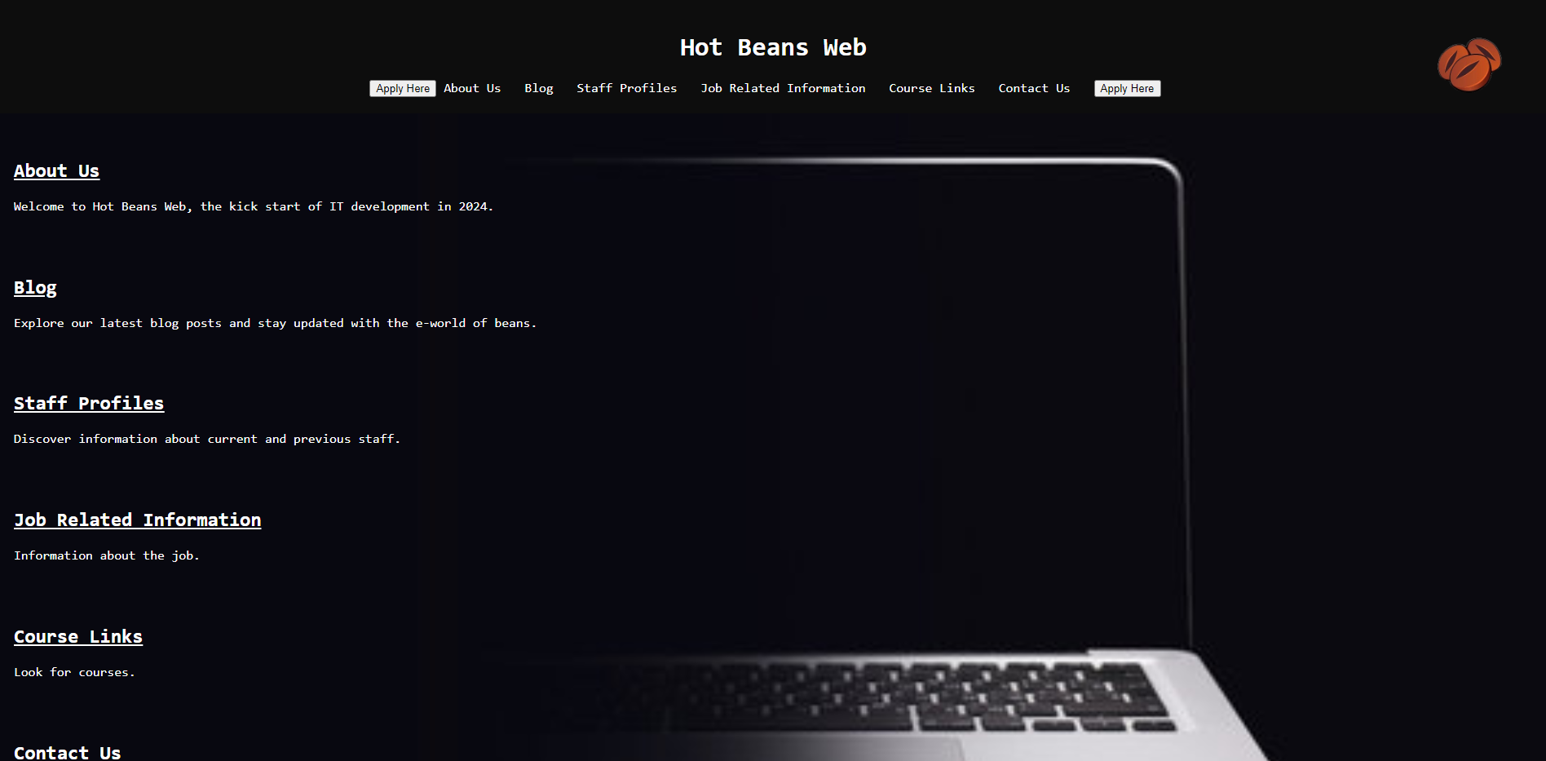

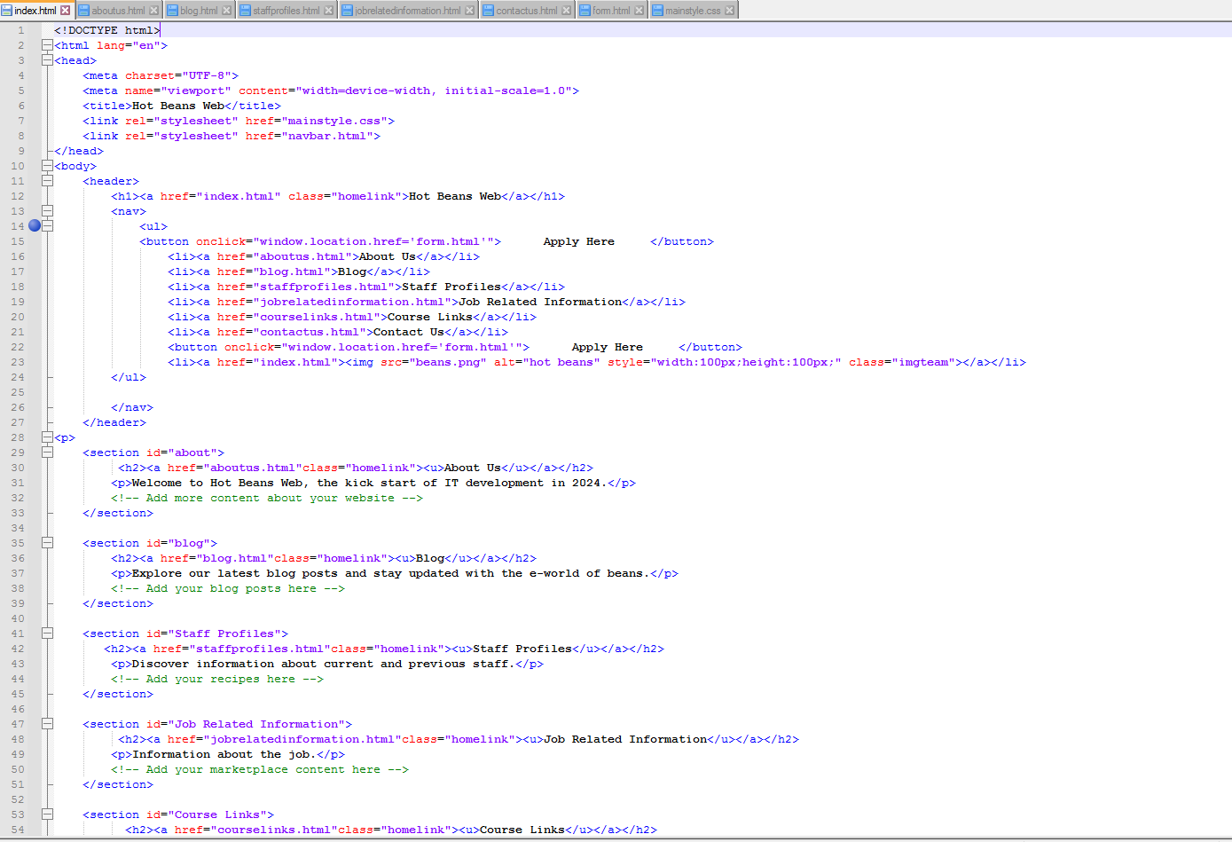

Document type is html, the main title seen on all pages will be “Hot Beans Web”, the stylesheet that will apply to all pages is mainstyle.css and navbar.html, <section> creates a clickable section with information.

APPLICATION FORM

|  |  |  |  |  |  |  |
| --- | --- | --- | --- | --- | --- | --- |
| Test Number | Button Pressed | What page | Test Data | Expected Result | Actual Result | Comments |
| 1 | Full name | APPLICATION FORM | Enter data in the name box | Allow the person to type in the box | Allows the person to type in the box | X |
| 2 | Address | APPLICATION FORM | Enter data in the address box | Allow the person to type in the box | Allows the person to type in the box | X |
| 3 | Phone number | APPLICATION FORM | Enter data in the phone number box | Allow the person to type in the box | Allows the person to type in the box | X |
| 4 | Date of Birth | APPLICATION FORM | Enter data in the date of birth box | Allow the person to type in the box | Allows the person to type in the box | X |
| 5 | Ethnicity | APPLICATION FORM | Enter data in the ethnicity box | Allow the person to type in the box | Allows the person to type in the box | X |
| 6 | Where did you hear about us (optional) | APPLICATION FORM | Enter data in the box (optional) | Allow the person to type in the box | Allows the person to type in the box | x |
| 7 | Attach CV/Cover letter | APPLICATION FORM | Click to attach | Allow person to attach something from their own device | Allows person to attach a file | x |
| 8 | Submit | APPLICATION FORM | Click the submit button | Submit the request if all validation goes through | Allows to submit if person has completed validation | x |

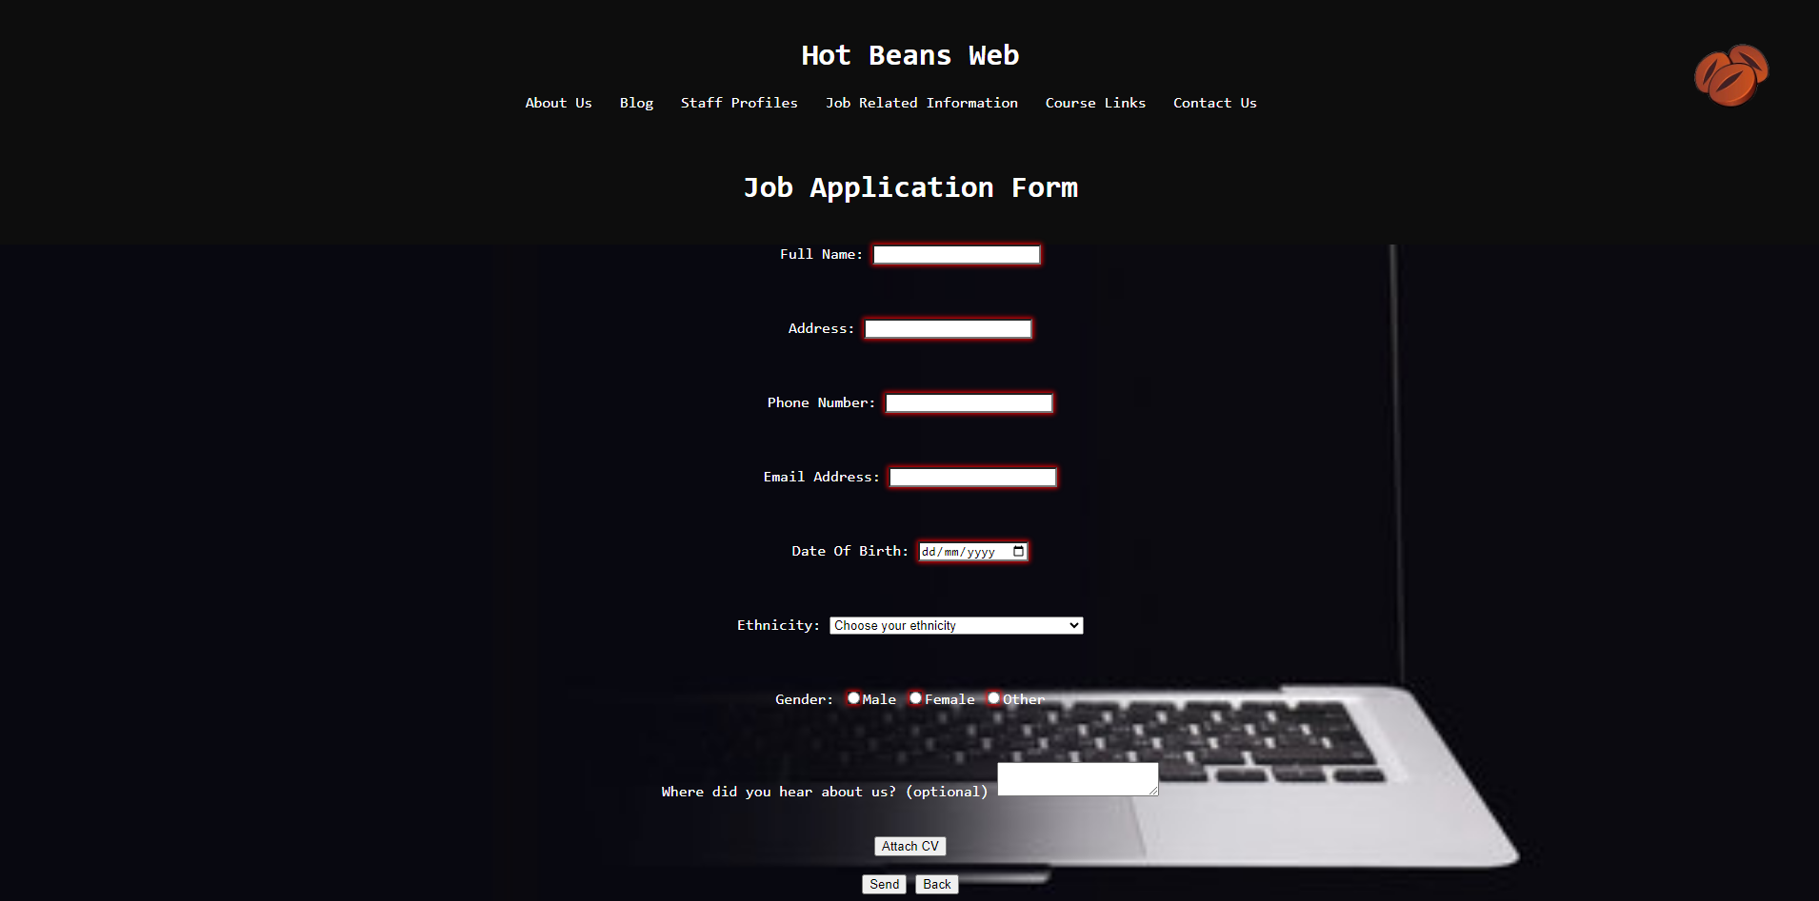

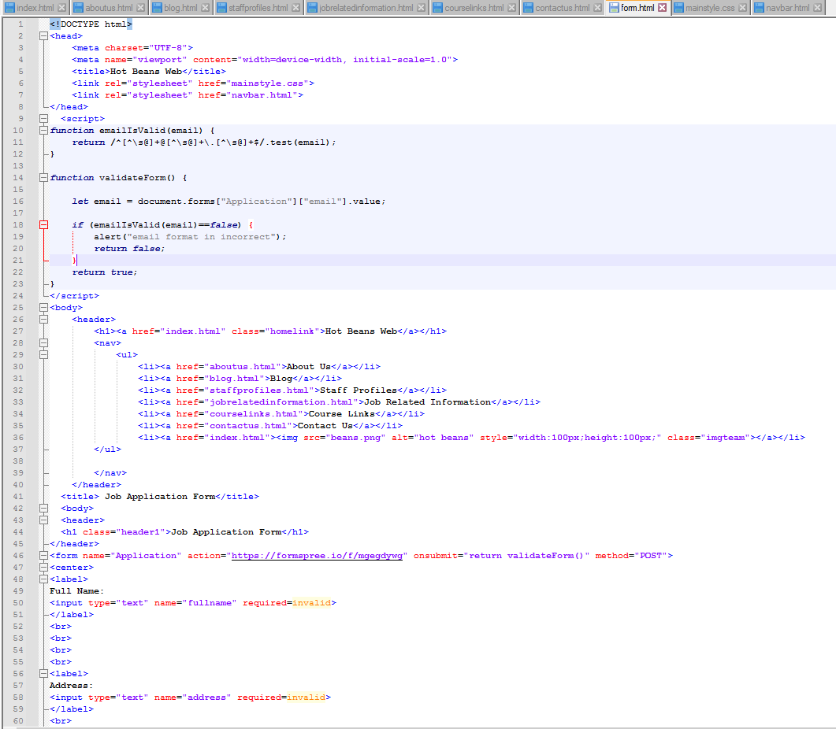

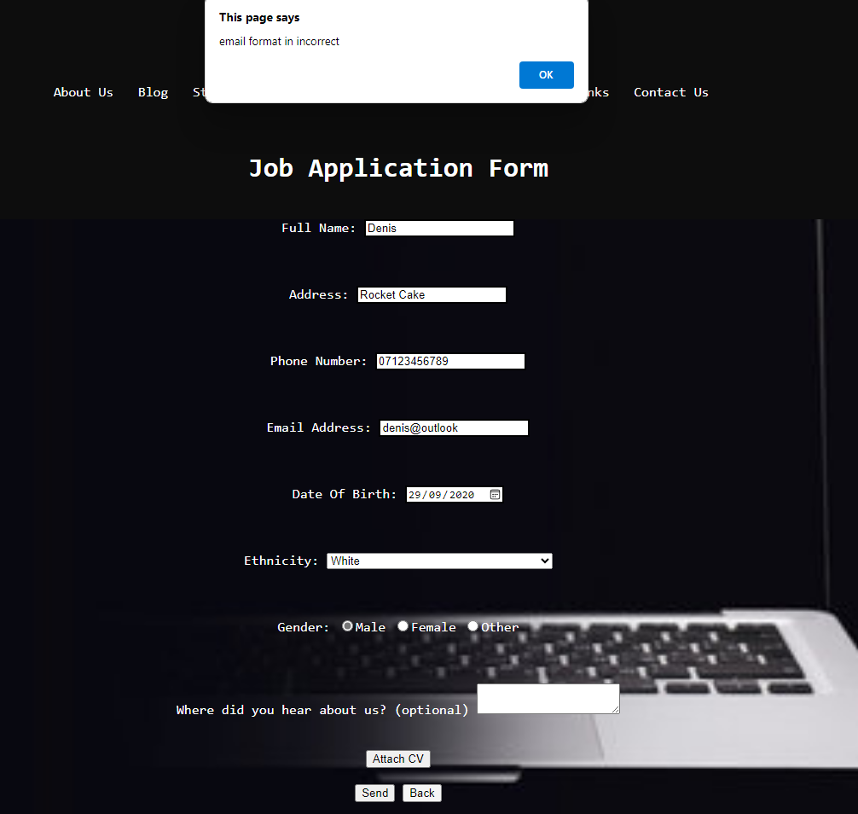

Validation can be seen here where the form can't be submited if the email isn't in the right format.

As it is a form, it has a title and a header. It has a javafunction validation and it requires input hence the “required=invalid” code.

ABOUT US

|  |  |  |  |  |  |  |
| --- | --- | --- | --- | --- | --- | --- |
| Test Number | Purpose of test (button) | What page | Test data | Expected Result | Actual Result | Comments and Actions Taken |
| 1 | LOGO/Home page | ABOUT US | Click the logo button | Redirect to the home page | Redirected to the home page | x |
| 2 | Instagram logo | ABOUT US | Click the instagram logo | Redirect to our Instagram page | Redirected to the Instagram page | x |
| 3 | Facebook logo | ABOUT US | Click the facebook logo | Redirect to our Facebook page | Redirected to the Facebook page | x |
| 4 | Contact us | ABOUT US | Click the contact us logo | Redirect to contact us page | Redirected to the contact us page | x |

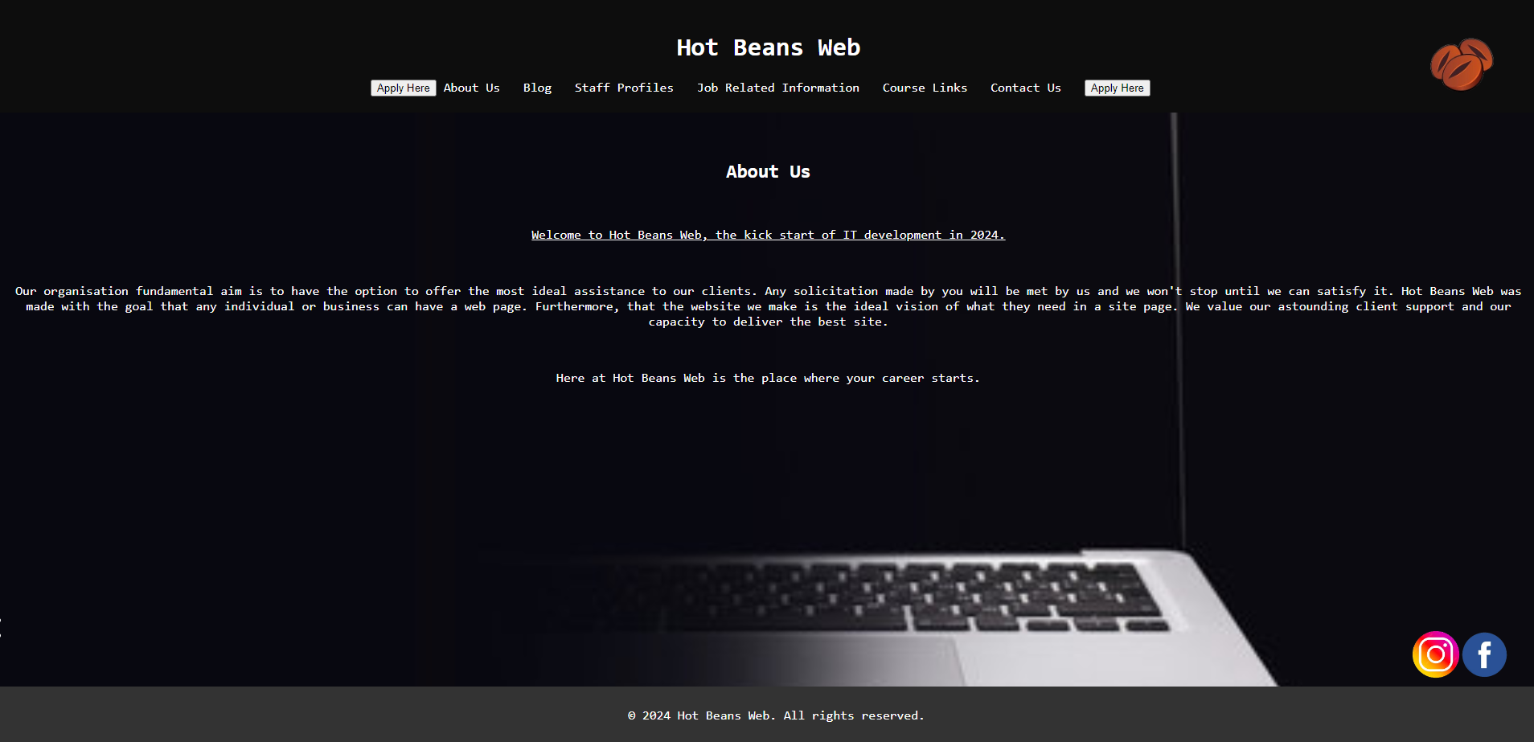

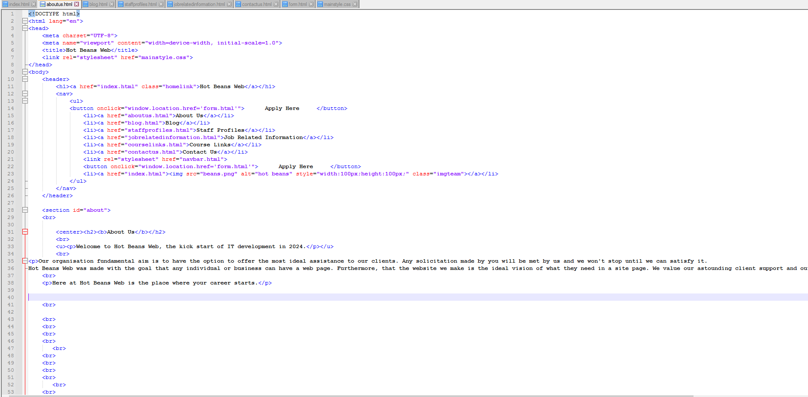

Another html code, It contains the same title as on every other page, it includes a navigation bar same as all the other pages. The button function redirects the user to a different page where the form is situated. The <p> function allows me to enter text and the <center> function centres the text on the middle of the page.

BLOG

|  |  |  |  |  |  |  |
| --- | --- | --- | --- | --- | --- | --- |
| Test Number | Button Pressed | What page | Test Data | Expected Result | Actual Result | Comments |
| 1 | LOGO/Home page | BLOG | Click the logo button | Redirect to home page | Redirected to the home page | x |
| 2 | 1 topic | BLOG | Click a topic | Redirect to topic (further details) | Redirected to the topic | x |
| 3 | Instagram logo | BLOG | Click the instagram logo | Redirect to our Instagram page | Redirected to the Instagram page | x |
| 4 | Facebook logo | BLOG | Click the facebook logo | Redirect to our Facebook page | Redirected to the Facebook page | x |
| 5 | Contact us | BLOG | Click the contact us button | Redirect to contact us page | Redirected to the contact us page | x |

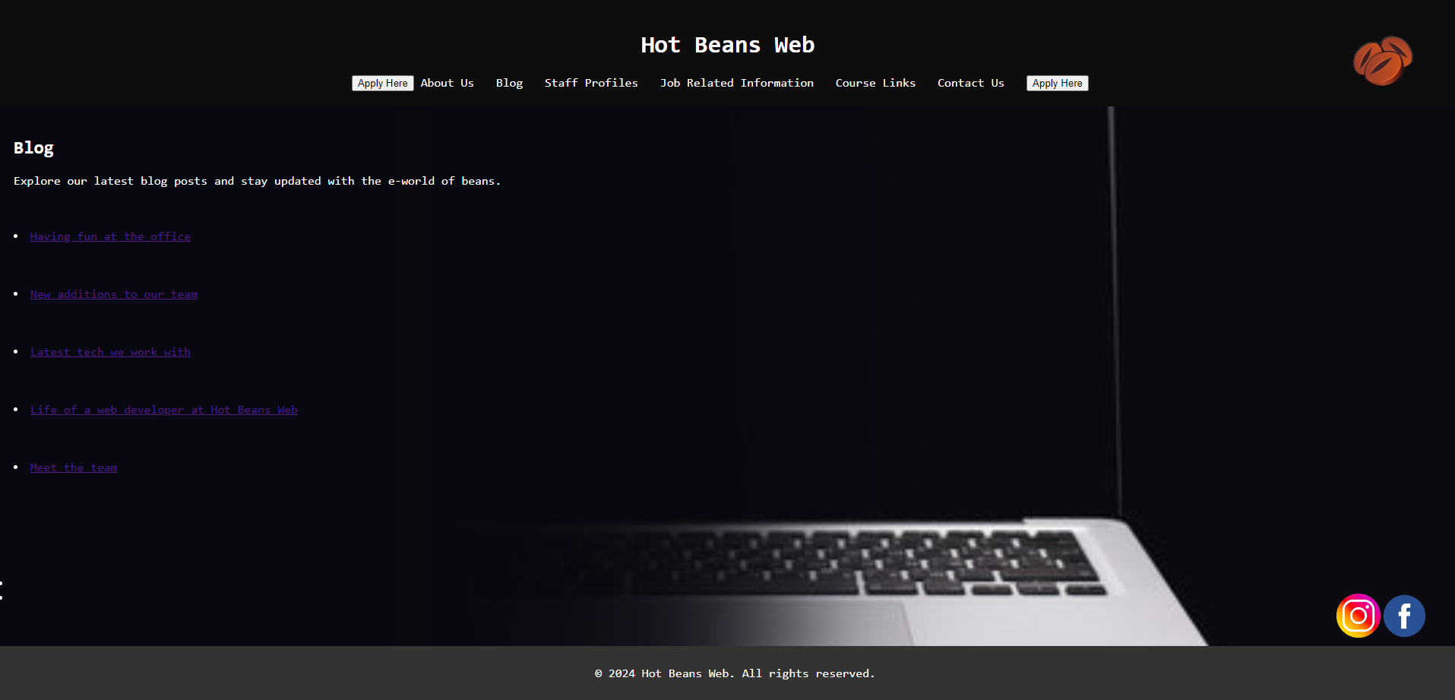

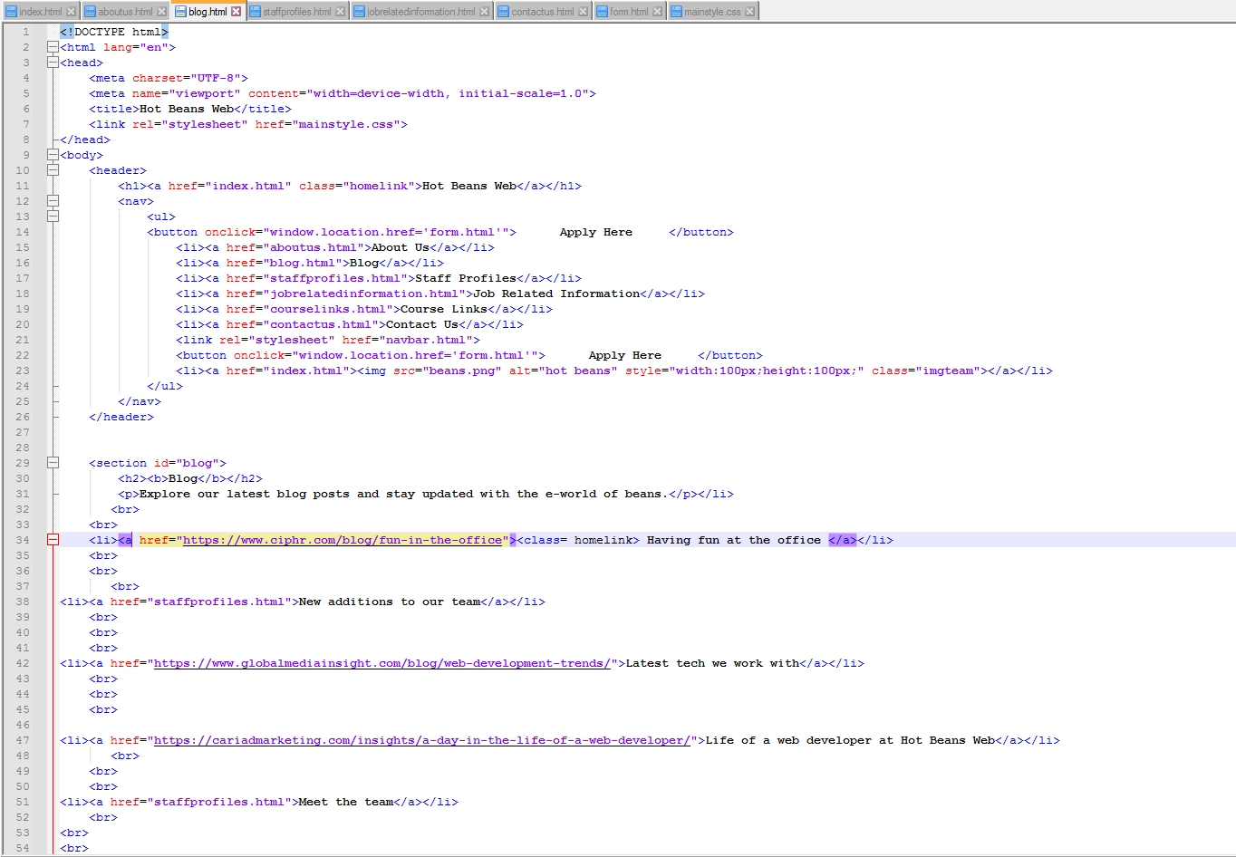

HTML document following the same stylesheets and navigation. The href creates a hyperlink which when the text is clicked, redirects the user to a different web page.

STAFF PROFILES

|  |  |  |  |  |  |  |
| --- | --- | --- | --- | --- | --- | --- |
| Test Number | Button Pressed | What page | Test Data | Expected Result | Actual Result | Comments |
| 1 | LOGO/Home page | STAFF PROFILES | Click the logo button | Redirect to home page | Redirected to the home page | x |
| 2 | Instagram logo | STAFF PROFILES | Click on the instagram logo | Redirect to our Instagram page | Redirected to the Instagram page | x |
| 3 | Facebook logo | STAFF PROFILES | Click on the facebook logo | Redirect to our Facebook page | Redirected to the Facebook page | x |
| 4 | Contact us | STAFF PROFILES | Click the contact us button | Redirect to contact us page | Redirected to the contact us page | x |

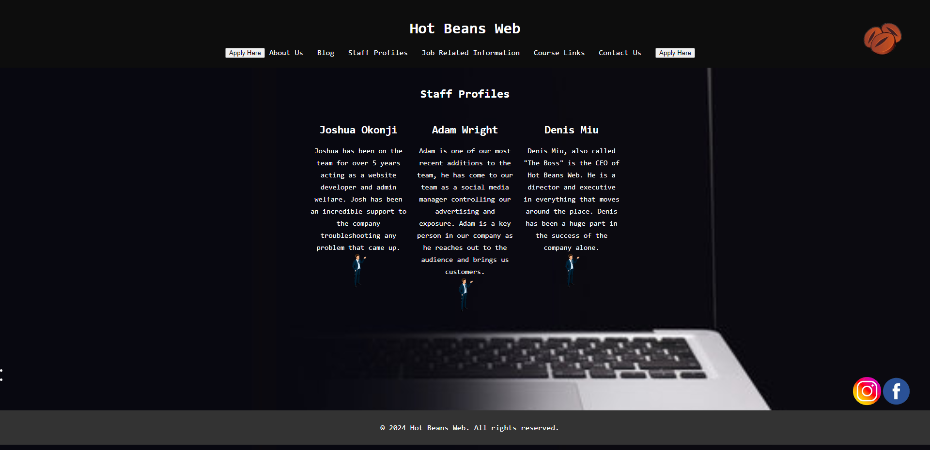

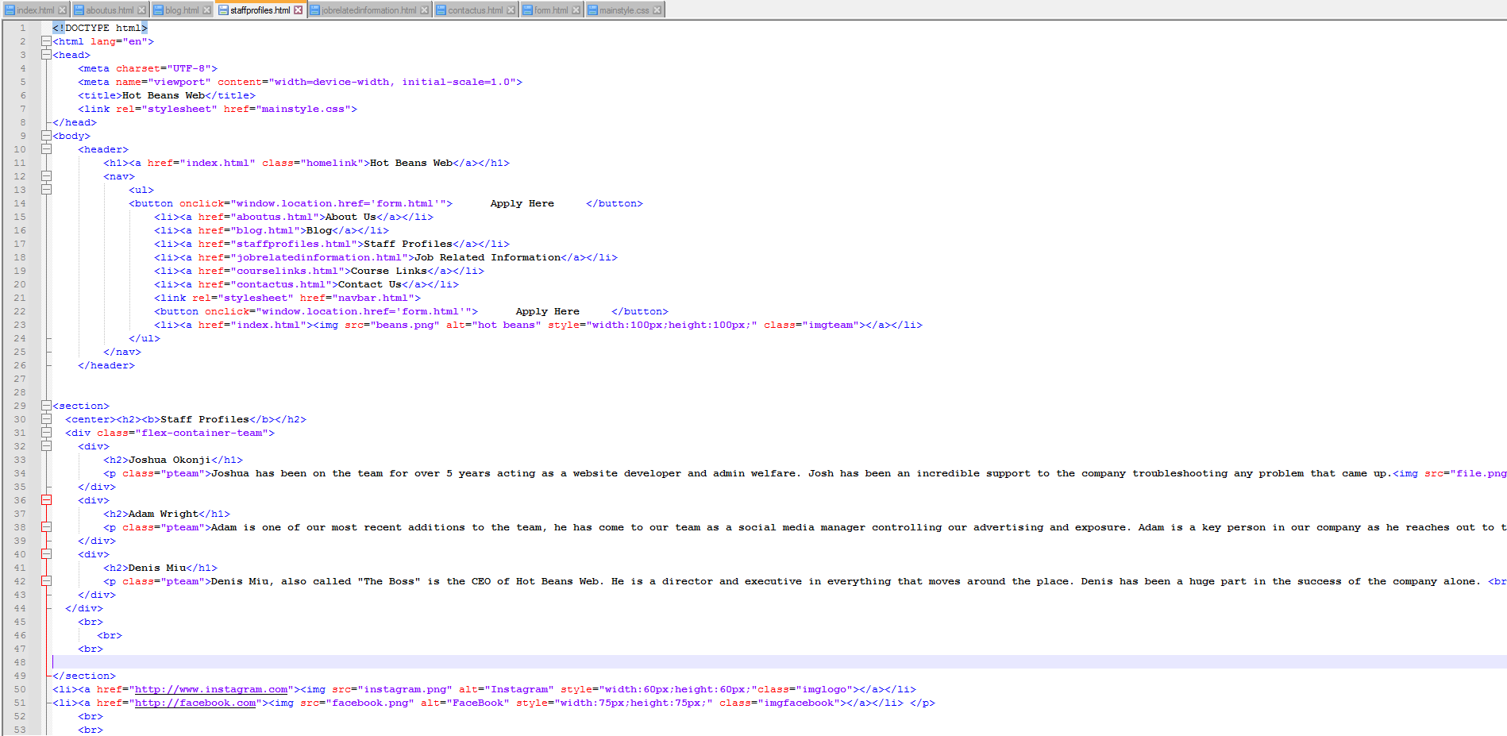

JOB RELATED INFORMATION

|  |  |  |  |  |  |  |
| --- | --- | --- | --- | --- | --- | --- |
| Test Number | Button Pressed | What page | Test Data | Expected Result | Actual Result | Comments |
| 1 | LOGO/Home page | JOB RELATED INFORMATION | Click the logo button | Redirect to home page | Redirected to the home page | x |
| 2 | 1 Job | JOB RELATED INFORMATION | Click to apply on a job | Redirect to a page where more information is suppled about that job. | Redirected to the job page | x |
| 3 | Instagram logo | JOB RELATED INFORMATION | Click the instagram logo | Redirect to our Instagram page | Redirected to the Instagram page | x |
| 4 | Facebook logo | JOB RELATED INFORMATION | Click the facebook logo | Redirect to our Facebook page | Redirected to the Facebook page | x |
| 5 | Contact us | JOB RELATED INFORMATION | Click the contact us button | Redirect to contact us page | Redirected to the contact us page | x |

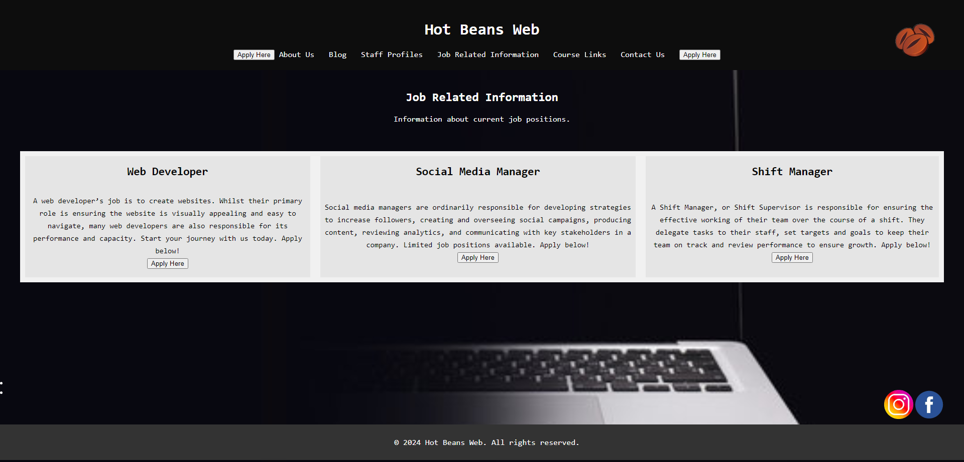

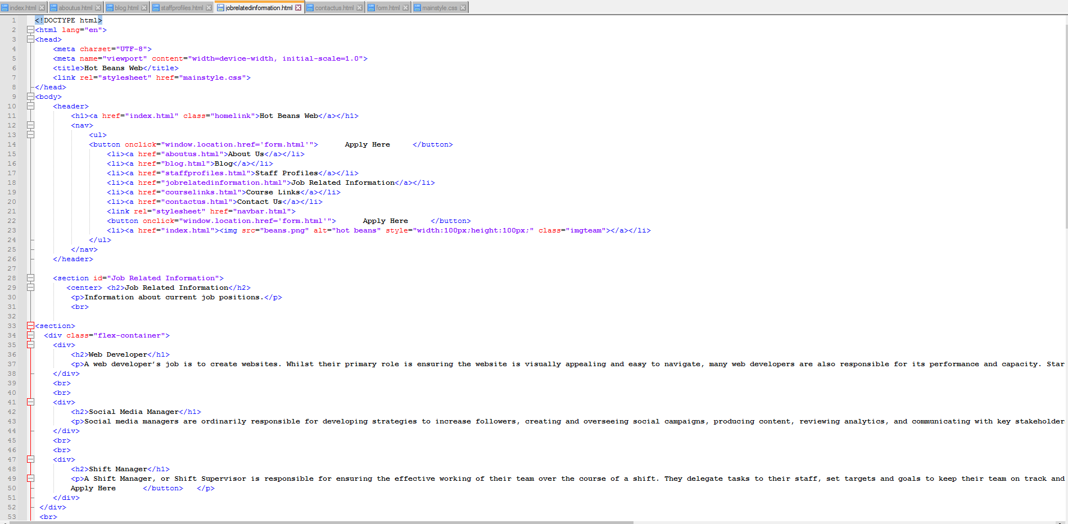

The flex-container function allows the website to list/row the different functions so it can be seen in any format or on any device. <h2> is a header.

COURSE LINKS

|  |  |  |  |  |  |  |
| --- | --- | --- | --- | --- | --- | --- |
| Test Number | Button Pressed | What page | Test Data | Expected Result | Actual Result | Comments |
| 1 | LOGO/Home page | COURSE LINKS | Click the logo button | Redirect to home page | Redirected to the home page | x |
| 2 | 1 Course | COURSE LINKS | Click on a course link | Redirect to specific course | Redirected to the course page | x |
| 3 | Apply button | COURSE LINKS | Click on an apply button | Redirect to application form for the course | Redirected to the application form page | x |
| 4 | Instagram logo | COURSE LINKS | Click on the instagram logo | Redirect to our Instagram page | Redirected to the Instagram page | x |
| 5 | Facebook logo | COURSE LINKS | Click on the facebook logo | Redirect to our Facebook page | Redirected to the Facebook page | x |
| 6 | Contact us | COURSE LINKS | Click on contact us button | Redirect to contact us page | Redirected to the contact us page | x |

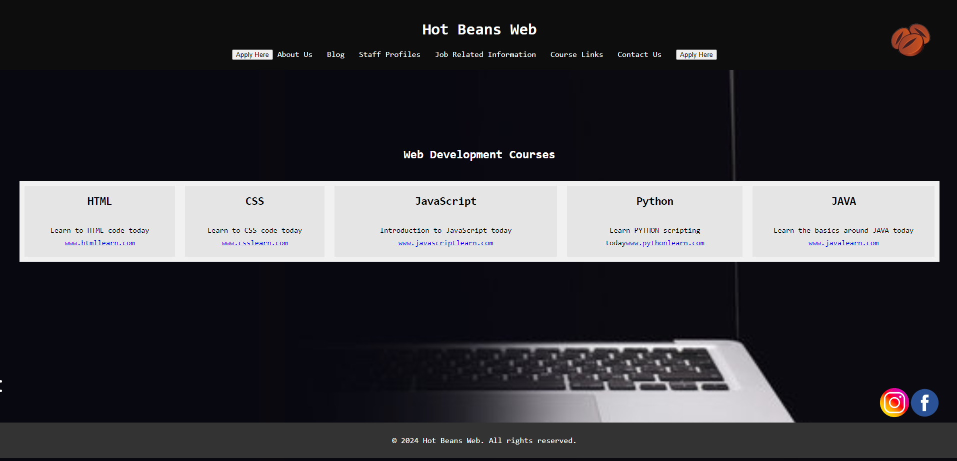

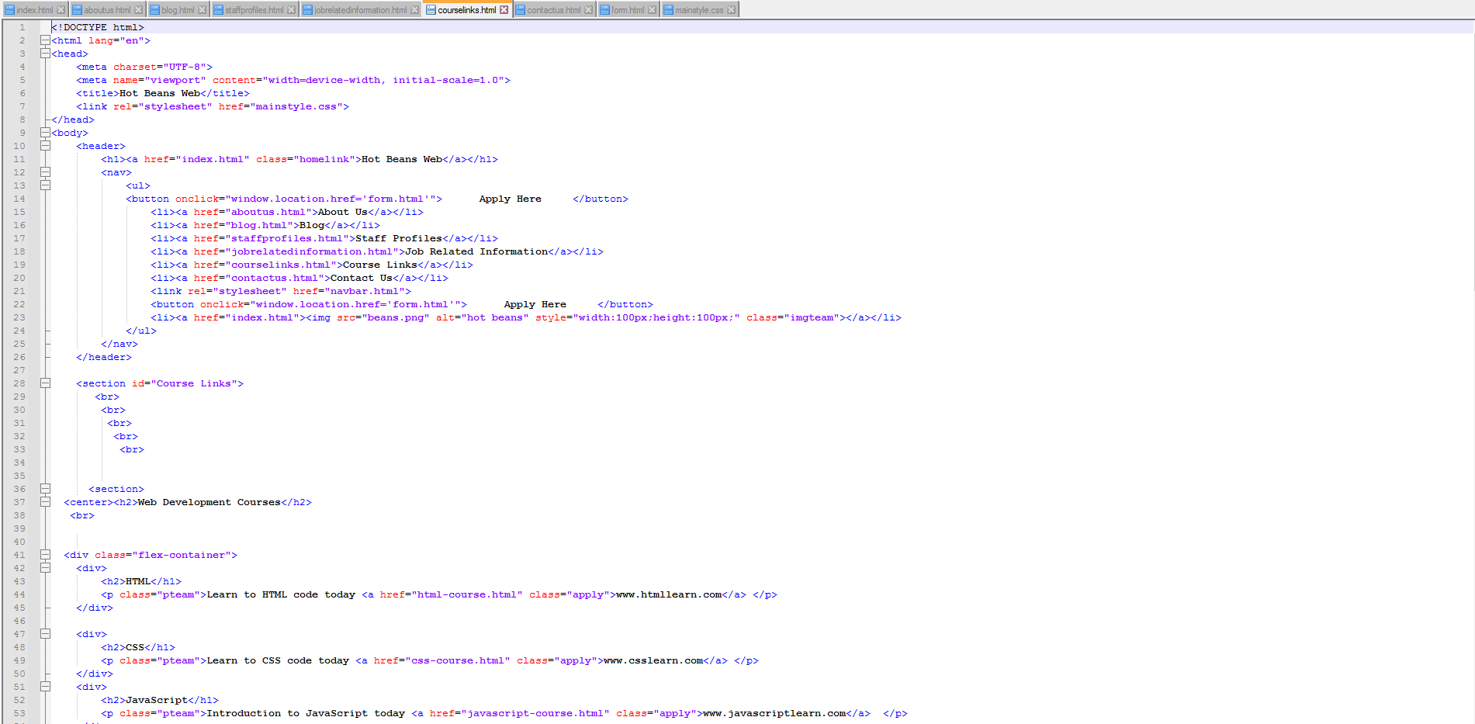

The class links to the mainstyle.css making all the pages look the same. The “sec” includes an image and the “style” allows the picture/text to follow a certain style.

CONTACT US

|  |  |  |  |  |  |  |
| --- | --- | --- | --- | --- | --- | --- |
| Test Number | Button Pressed | What page | Test Data | Expected Result | Actual Result | Comments |
| 1 | LOGO/Home page | CONTACT US | Click on the logo button | Redirect to home page | Redirected to the home page | x |
| 2 | Instagram logo | CONTACT US | Click the instagram logo | Redirect to our Instagram page | Redirected to the Instagram page | x |
| 3 | Facebook logo | CONTACT US | Click the facebook logo | Redirect to our Facebook page | Redirected to the Facebook page | x |

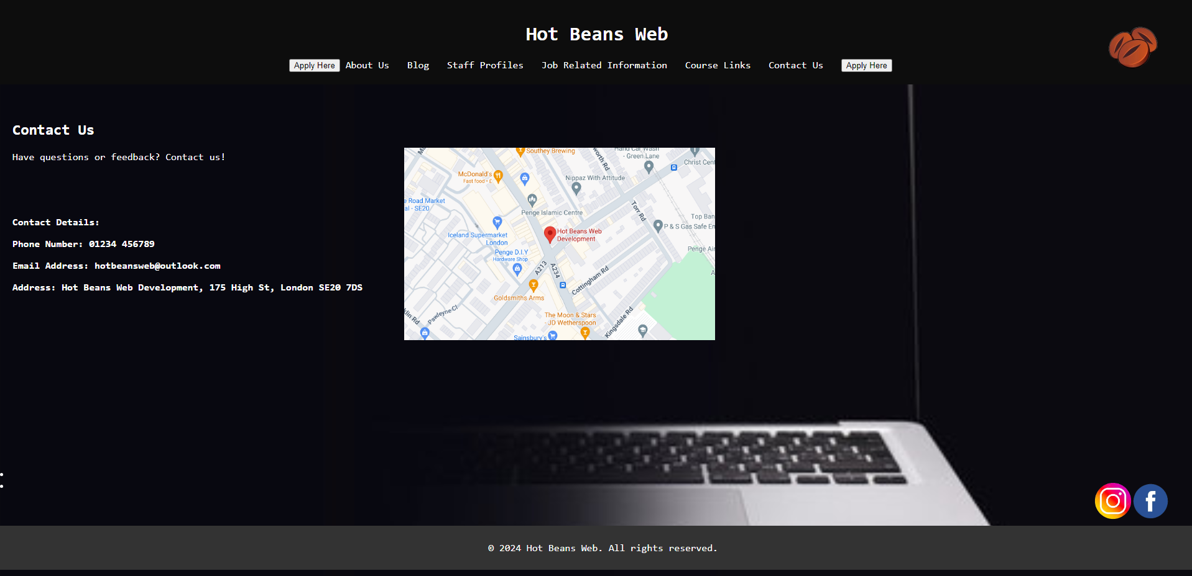

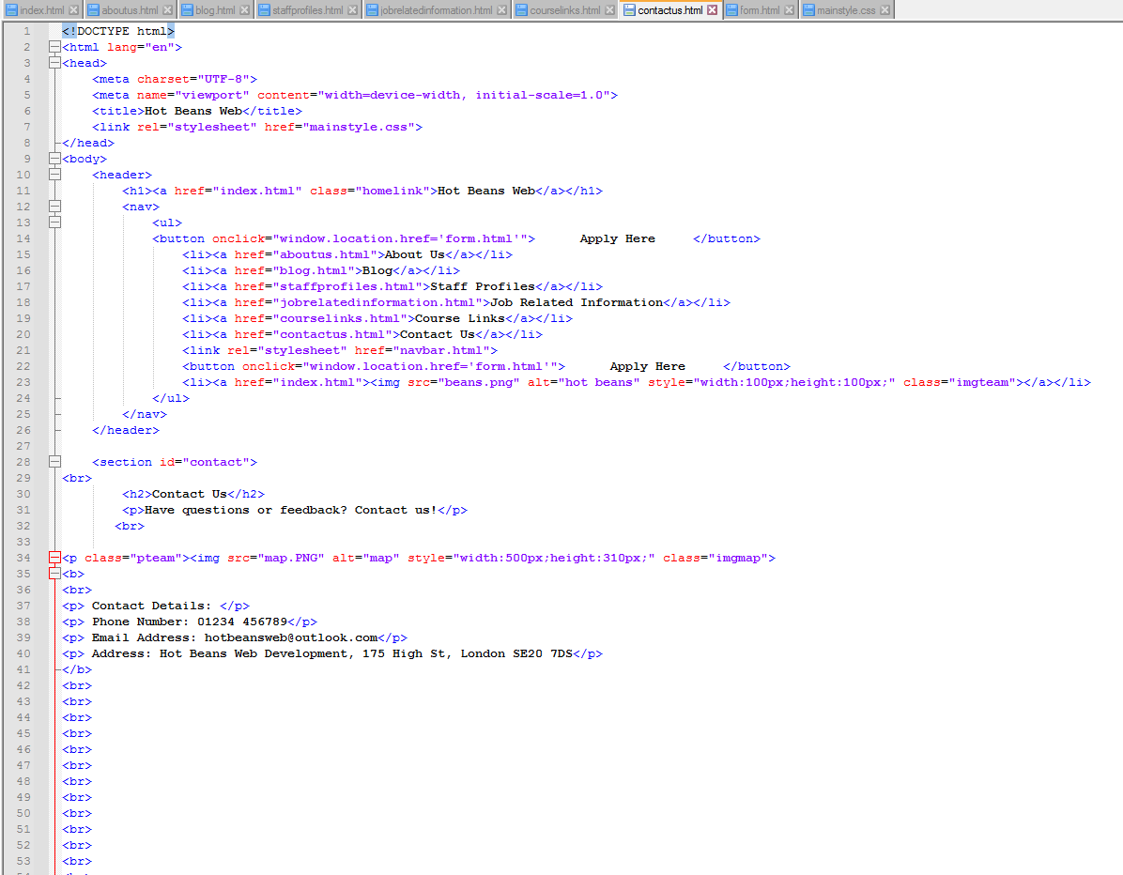

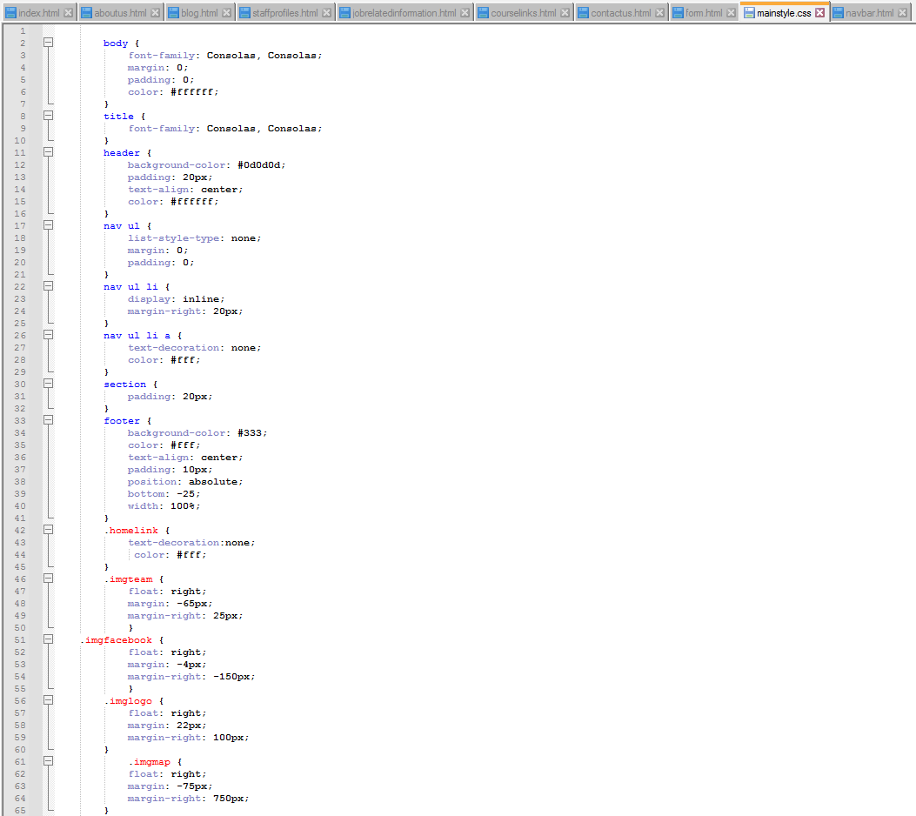

The body/header/nav/section functions allow all of the pages to follow the same algorithm. The functions in red only work for certain functions e.g. pictures on a specific page or the logo being in the same place on all pages. The title controls what font the title is, the body controls what font the rest of the writing throughout the site is. The color is #ffffff as i wanted black background with white writing over it.

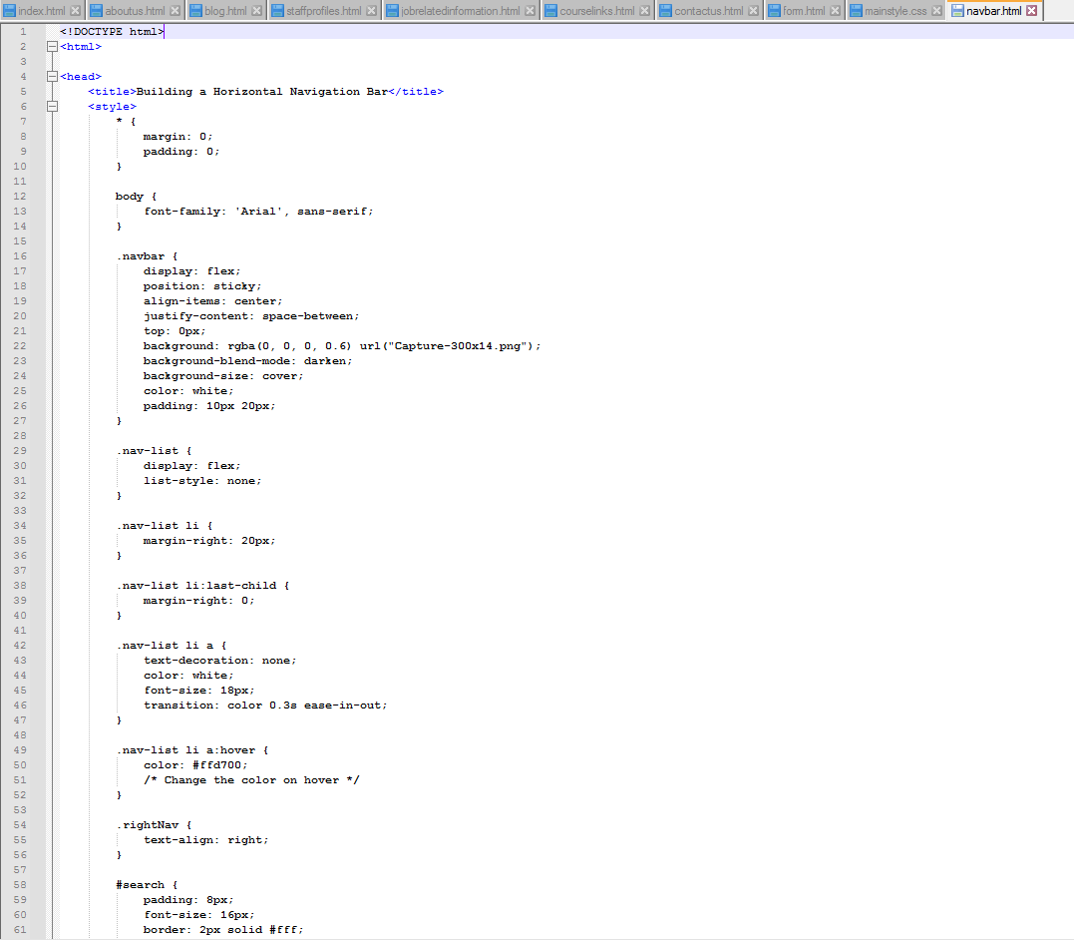

The navbar is pretty straight forward, it allows navigation around the site and follows the clicks that tell the computer where to redirect the user. The body is the main font that is used across all of the pages to make it look clean.

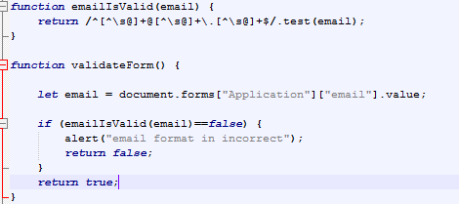

This is the JavaSCRIPT which runs the validation of the email address. It makes sure the email format is valid and valdiates if the email includes @ and .co.uk/com/etc. If all is valid, the validation returnds true and form is sent.

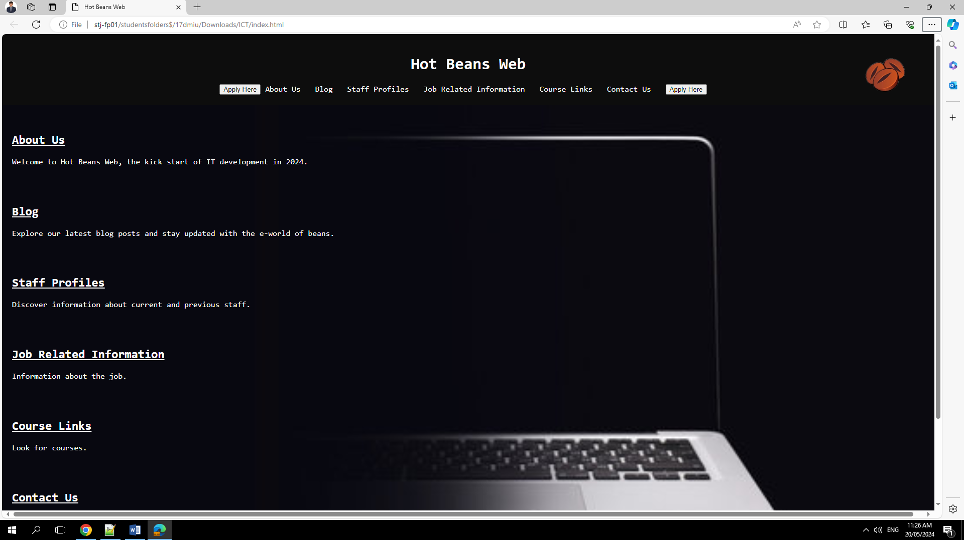

I've tested to see if the website works on different browsers, here i have used Microsoft Edge instead of Google Chrome because it was the only one i had available to use, the website works and does the same things as on Chrome. 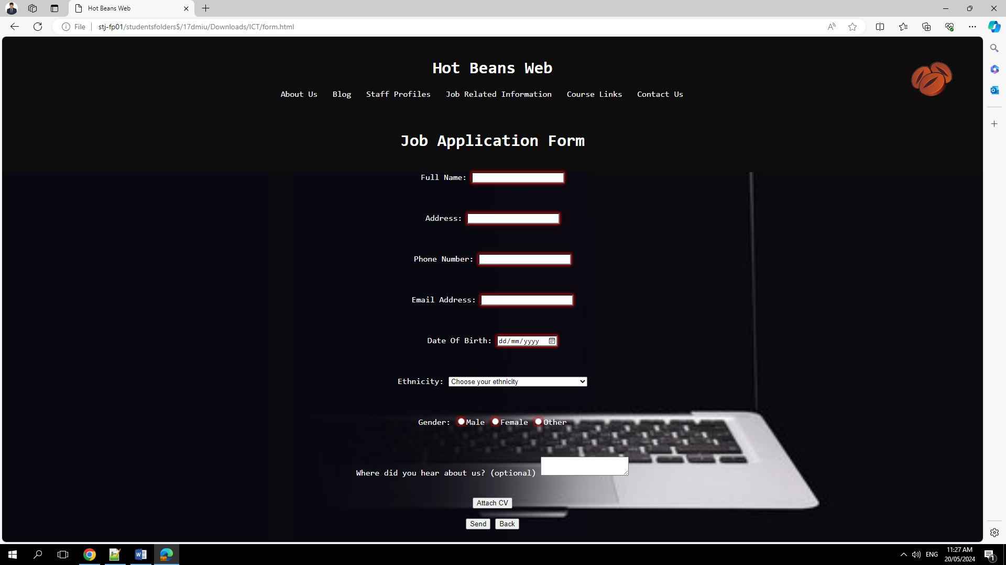

# Justify Plan

I have decided to go with wireframe 1 for my home page as it seemed to me to be more clear and easier to work around. The other design did not match the rest of my plan.

The design meets the client requirements by aiming for the proposed intended audience (university and sixth form leaving students) as the website isn’t easy nor hard to use. You just need basic knowledge of how a website works to navigate it. The problems will be solved as I think I’ve made it pretty clear that we are looking for employees and that the apply for the job button is on every page. People browsing my website will have a pleasure viewing it as I consider my website to be very clean and very well laid out, people will benefit by applying to work for us and getting a job, also people will benefit by having free courses linked to our website which they can learn/follow. My website is very interactive and allows people to interact with it. It responds to all the functions that it holds and it is very complex (has everything you need).

I think my only challenge completing this was that it was my first time working with HTML and I sometimes had trouble understanding what and where a code goes and what it does.

I found it a challenge having more pages than normal for my website as i had to include the code over more pages. It was difficult because i had to change them up and not make them all look the same, i had to keep it entertaining. I think i did a good job tackling this challenge and i completed everything.

[**https://denismiu.github.io/denis2/**](https://denismiu.github.io/denis2/)